Time Series Analysis using Facebook Prophet
Last Updated : 07-07-2025 (Monday)

Time series analysis is one of the important methodologies that helps us to understand the hidden patterns in a dataset that is too related to the time at which it is being recorded. The article aims to explore the fundamentals of time series analysis and demonstrates the analysis using Facebook Prophet.
Table of Content
- What is Time Series Analysis?
- Facebook Prophet Library
- Understanding the Prophet Model
- Need of Facebook Prophet
- Implementation - Analyzing Time Series Data using Prophet

What is Time Series Analysis?
Time series analysis is a statistical approach that entails gathering data at consistent intervals to recognize patterns and trends. This methodology is employed for making well-informed decisions and precise forecasts by leveraging insights derived from historical data.
And the process of predicting the future values of the data by analyzing the previous trends and patterns hidden in the data is known as time series forecasting. Time series forecasting can be done using various forecasting techniques like ARIMA, SARIMA, Prophet, Theta and other statistical method. Time series data is a sequential data hence, deep learning-based methods like RNN, LSTM, BLSTM and GRU are also used for time series forecasting.

Key components of Time Series analysis
The key components of time series analysis include:
- Time series data commonly displays temporal relationships, meaning that the values at a particular moment are impacted by preceding values. Grasping these dependencies is essential for accurate predictions and gaining valuable insights.
- Trend analysis involves recognizing the fundamental direction or long-term movement in a time series, whether it is upward, downward, or stable. This understanding provides insights into the overall trajectory of the data.
- Seasonal patterns, observed in numerous time series, depict recurring cycles at fixed intervals, such as daily, monthly, quarterly, or yearly. Analyzing these patterns through seasonal analysis helps identify and comprehend their periodic nature.
- Time series data often incorporates random fluctuations or noise that lacks a specific trend or pattern. It is crucial to eliminate this noise to unveil meaningful information within the data.

Facebook Prophet Library
Prophet is an open-source tool from Facebook used for forecasting time series data which helps businesses understand and possibly predict the market. It is based on a decomposable additive model where non-linear trends fit with seasonality, it also takes into account the effects of holidays. Before we head right into coding, let's learn certain terms that are required to understand this.
- Trend: The trend shows the tendency of the data to increase or decrease over a long period of time and it filters out the seasonal variations.
- Seasonality: Seasonality is the variations that occur over a short period of time and is not prominent enough to be called a "trend".

Understanding the Prophet Model
The general idea of the model is similar to a generalized additive model. The "Prophet Equation" fits, as mentioned above, trends, seasonality, and holidays. This is given by,
y(t) = g(t) + s(t) + h(t) + e(t)
here,
- g(t) refers to trend (changes over a long period of time)
- s(t) refers to seasonality (periodic or short-term changes)
- h(t) refers to effects of holidays to the forecast
- e(t) refers to the unconditional changes that is specific to a business or a person or a circumstance. It is also called the error term.
- y(t) is the forecast.

Need of Facebook Prophet
We need it because, although the basic decomposable additive model looks simply, the calculation of the terms within is hugely mathematical. If you do not know what you are doing, it may lead to making wrong forecasts, which might have severe repercussions in the real world. So, to automate this process, we are going to use Prophet. However, to understand the math behind this process and how Prophet actually works, let's see how it forecasts the data.
Prophet provides us with two models (however, newer models can be written or extended according to specific requirements).
- Logistic Growth Model
- Piece-Wise Linear Model
By default, Prophet uses a piece-wise linear model, but it can be changed by specifying the model. Choosing a model is delicate as it is dependent on a variety of factors such as company size, growth rate, business model, etc., If the data to be forecasted, has saturating and non-linear data (grows non-linearly and after reaching the saturation point, shows little to no growth or shrink and only exhibits some seasonal changes), then logistic growth model is the best option. Nevertheless, if the data shows linear properties and had growth or shrink trends in the past then, the piece-wise linear model is a better choice. The logistic growth model is fit using the following statistical equation,
g(t)=C1+e−k(t−m)g(t)=1+e−k(t−m)C​
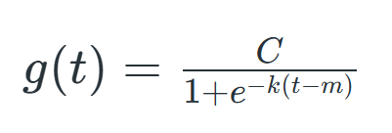
where,
- C is the carrying capacity
- k is the growth rate
- m is an offset parameter
The piece-wise linear model is fit using the following statistical equations,
y={β0+β1x,if x≤c,β0−β2c+(β1+β2)x,if x>c.y={β0​+β1​x,β0​−β2​c+(β1​+β2​)x,​if x≤c,if x>c.​
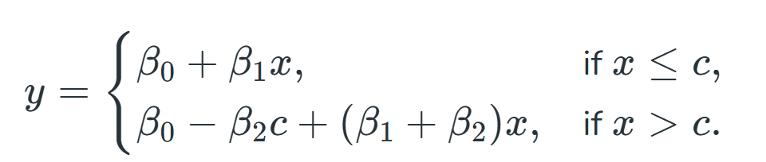

where c is the trend change point (it defines the change in the trend).? is the trend parameter and can be tuned as per requirement for forecasting.

